CHAPTER 1 INTRODUCTION

  - Introduction
Crime is an important social problem in the country, affecting public safety, children development, and adult socioeconomic status. A police officer may know where the dangerous areas are according to his experience, but he may not be able to tell about what kind of crime could happen. Our objective is to help police officers by providing useful information which is hard to get, so that they can take appropriate measures. We have used Apache spark’s Random Forest and SciKit-learn’s KNN classifier and ensemble method for the same. Our project has below two parts.
There is a rapid increase in crime in almost every country. There is a strong need to identify crime patterns and analyze different areas of crime. Security agencies all over countries are working hard to reduce these crimes, however, size of crime information is increasing rapidly, and it becomes difficult to manage such a huge amount of data and to keep record of crimes that are geographically widespread and at different time period. Thus. it is very necessary to have a crime information system which can process large amount of data in short period of time. Data mining using clustering,
classification, association mining is one of the most effective ways to explore, analyze, detect patterns and predict future crimes in huge amount of data. News and records indicate that there have been a large number of crimes in Chicago city. It is called as “murder capital” or “crime capital” of the U.S in 2012. Chicago had more murders in 2012 than any other city in the country. There were 500 murders in Chicago last year; the FBI said which were highest in entire nation. Also, there has been a report by New York Times which states that Rate of Killings Rises 38 Percent in Chicago in 2012. Therefore, there is a requirement to make more informed decisions and analyze crimes occurring in different region of Chicago city. By the help of data mining we can detect different patterns and therefore benefit the residents of Chicago city by employing the correct resources at correct time and place. This will help in utilizing maximum efficiency of security departments and help prevent crime in the city.

  - Aim
The aim of crime analysis in Chicago City, as in many other cities, is to utilize data and analytical methods to better understand and address crime and public safety issues. Crime analysis plays a crucial role in law enforcement and community safety efforts by providing valuable insights and informing decision-making processes.

  - Objectives
    - Use data and analytical methods to support law enforcement efforts.
    - Enhance public safety.
    - Reduce crime.

  - Motivation
The motivation behind crime analysis in Chicago City is rooted in a commitment to improving the quality of life for all residents by reducing crime, enhancing public safety, and fostering trust and collaboration between law enforcement agencies and the community. It is a multifaceted approach that recognizes the interconnectedness of safety, economic vitality, and social well-being in a thriving city.
  - Scope
    - Dynamic and continually evolving to adapt to changing crime patterns, technologies, and community needs.
    - It plays a pivotal role in supporting law enforcement agencies, city officials, and community stakeholders in their efforts to reduce crime, enhance public safety.
    - Improve the overall quality of life for residents.

  - Related Work
“Crime Pattern Detection Using Data Mining” by Shyam Varan Nath proposed idea of crime detection and said clustering algorithm using data mining can help to detect the crime patterns and speed up the process of solving crime by using K-means clustering algorithm. This paper applied clustering to real crime data from a sheriff’s office and alidated results. Author of this paper identified significant attributes; using expert based semi-supervised learning method and developed the scheme for weighting the significant attributes. This allows placing different weights on different attributes dynamically based on the crime types being clustered. This also allows weighing the categorical attributes. Limitation in this paper was that there was no prediction of the crime hot-spots that will help the police utilizing their resource for any given window of time.
“Detecting and Mapping Crime Hot Spots Based on Improved Attribute Oriented Induce Clustering” discusses about detecting high-crime-density areas. It says most useful method for detecting crime hotspots is the spatial clustering. Crime Data includes many various crime events such as event time, event class, event spatial information and event object. These data have many attributes at different levels. So the attribute oriented induce method is chosen to deal with these data. This paper presents an improved attribute oriented induce method and algorithm related to crime hot spots detecting and a simple mapping method is depicted. Limitation and future work for this paper is further design and optimization of taxonomy. Taxonomy of attribute is the key related to the accuracy of the results. The mapping method in this paper is relatively simple. Improving the mapping method is another important work later.
“Crime hotspot mapping using the crime related factors - a spatial data mining approach” also discusses about the use of Hotspot Mapping. Author says that spatial distribution of crime is considered to be related with a variety of socio-economic and crime opportunity factors but none of the existing techniques focus on it. In this study, a new crime hotspot mapping tool - Hotspot Optimization Tool (HOT) is introduced which is an application of spatial data mining. Experiments are done using a real-world dataset from a northeastern city in the United States and the pros and cons of utilizing related factors in hotspot mapping are discussed.

CHAPTER 2
MATERIAL AND METHODOLOGIES

4.1. Dataset:
The dataset chosen for this project consists of incidents of crime reported in the city of Chicago from 2001 to 2019. Data is extracted from the Chicago Police Department's CLEAR (Citizen Law Enforcement Analysis and Reporting) system. It is one of the richest data sources in the area of crime. The dataset includes enough information about Date, Type, Description, location etc about the crime for our analysis.

4.2. Approach and corresponding technologies:
The dataset contains 7 million records of the crime. Data of this size needs fast and efficient data processing. We have used Spark framework as its in-memory processing capability makes it easy to deal with data of this volume. We have implemented some techniques such as: k-fold cross validation, KNN, Random Forest, ensemble method and feature selection.

Below is the pipeline we followed:
- Data Pre-processing: In this step we chose data from year 2010-2019 as the accuracy stabilized for this time period.
- Dropped missing/null values as it accounted for <1% of data.
- Filtered out irrelevant features from the dataset.
- Reduced/merged number of crime types from 32 to 16.
- Used Random Over sampling/Under sampling techniques to balance the data.
Technologies: Apache Spark, pyspark Dataframe.
- Exploration Analysis:
In this step, we inferred useful information and analyzed important trends for crime detection and prevention. The analysis will also help identify useful features for building predictive models.
Methods: Bar graph, line graph, pie-chart, heatmaps, querying data.
Technologies: pyspark DataFrame, pyspark SQL, pyspark RDD, Matplotlib, Folium, Tableau.
- Predictive Analysis:
Below predictions were tried on both KNN and Random Forest and the results were compared with each other. Below are the steps involved:
- We used random split, k-Fold Cross-Validation technique while training.
- We further trained the model with additional features such as Location Description, Arrest etc. to achieve better accuracy.
- We transformed categorical data to binary vectors using One Hot Vector/ Label Encoding.
- Used ExtraTreesClassifier, Correlation Matrix/HeatMap, Principal Component Analysis (PCA) as feature selection techniques.
- Tuned the hyperparameters such as no of neighbors in KNN and no of trees in Random Forest.
- Used an ensemble of different classification models and used soft voting for output.
3.1. Predicting the type of crime (probabilities) based on its location:
We used latitude, longitude as location to predict the type of crime. We used vector assembler to transform two columns into a vector.
3.2. Predicting the crime based on time(week):
We used week as a feature to predict the crime based on time.

CHAPTER 3
RESULTS

4.1. Important Preprocessing Steps:
- Dataset Analysis - Our dataset was quite imbalanced and had a lot of features. Therefore, we tried making it balanced by merging similar types or dropping insignificant ones.
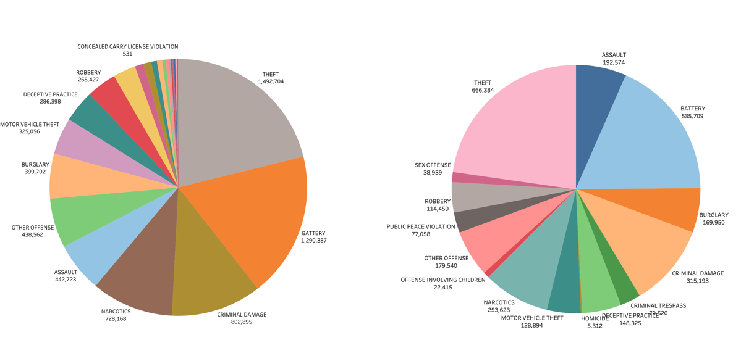

- Feature Extraction -
  - Feature importance in Extra Tree Classifier
  - Principal Component Analysis
  - Correlation Matrix/HeatMap.

Correlation Matrix/ HeatMap - The heatmap and matrix help us decide features which are in high correlation with Primary Type crime.

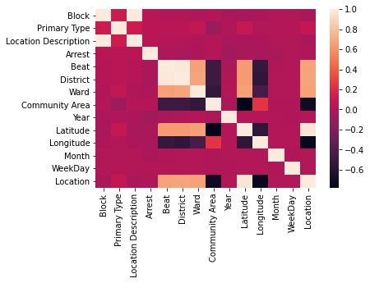
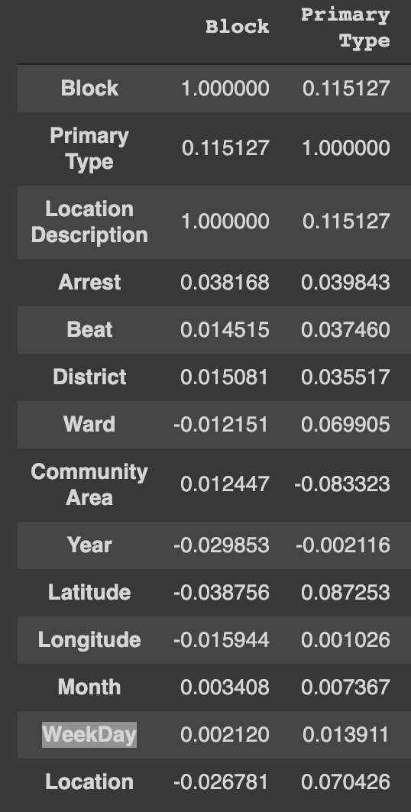

4.2. Exploratory Analysis:
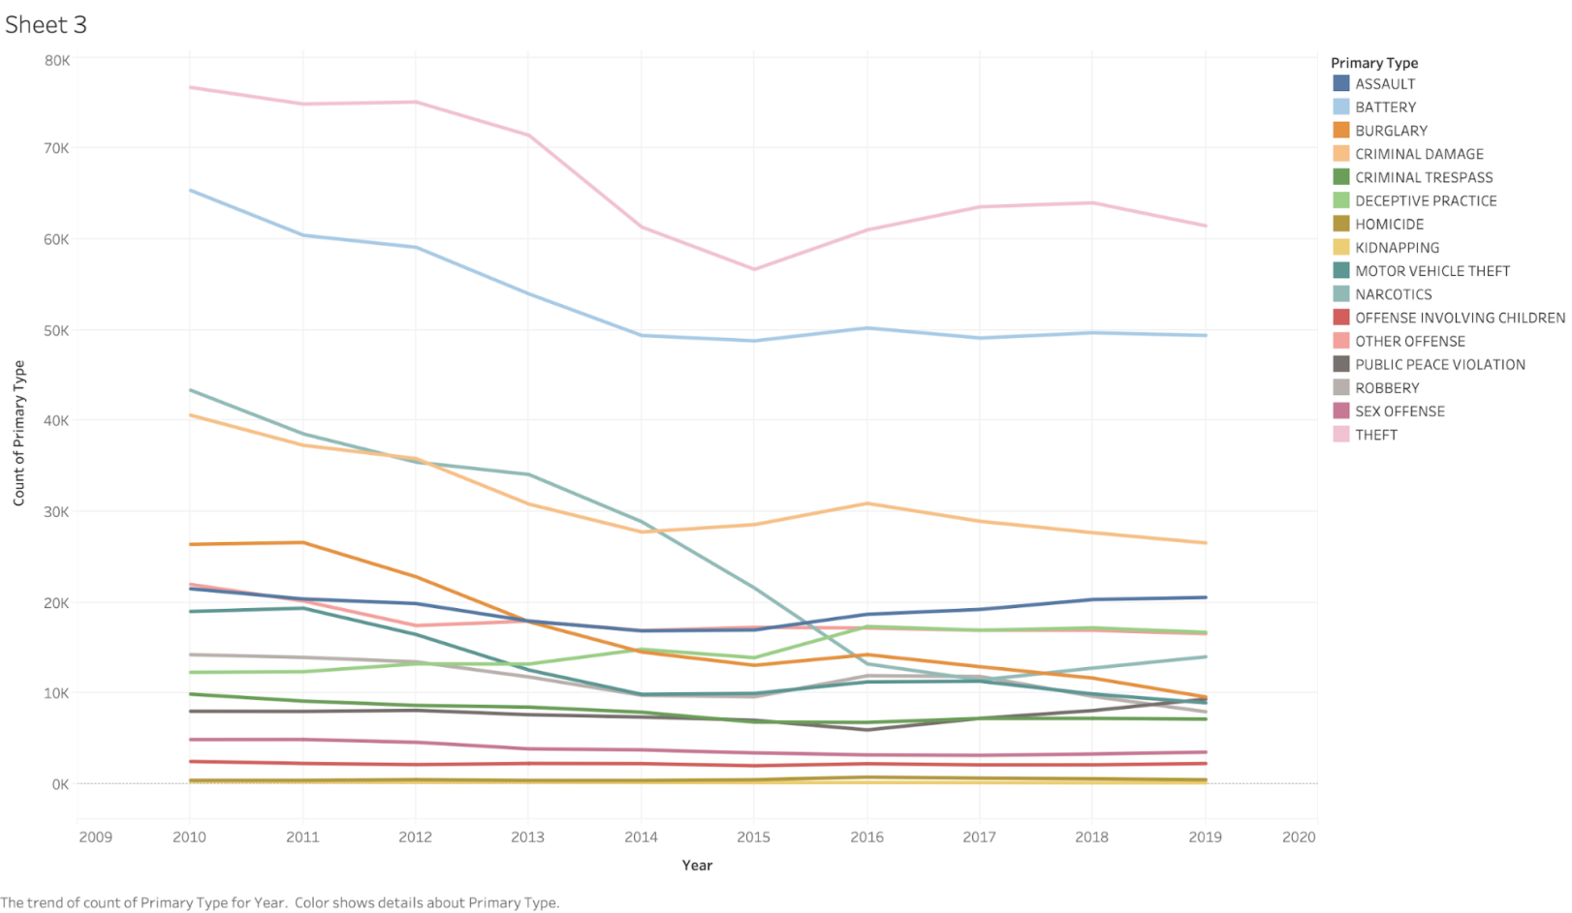
Trend of crime types across the past decades
4.3. Predictive Analysis:
Predicting the type of crime(s) and probability of crimes based on location and time data:

We concluded that location or time data alone donot provide sufficient details.
Predicting the type of crime(s) and probability of crimes based on both location and time data:
Random Forest Classifier
Grid-search and k-fold cross validation provided the best params for RF.

Results:
- Accuracy = 36.86%
- F1 score = 25.42%
Additionally providing crime probabilities.

KNN Classifier:
Finding optimal K, using the elbow method.

Optimum K = 25 Parameter tuning using Random Search and K-Fold cross-validation: 'weights' = ‘uniform ‘metric' = ‘manhattan' (Haversine - in case of Latitude and Longitude)
Accuracy comparison before and after training model with additonal features

Impact of sampling on the KNN model:
Model with no sampling:
- Accuracy - 33.5%
- F1 Score - 29.6%
UnderSampling
Sampling Technique | Accuracy | F1 Score
Cluster Centroids | 24.92% | 19.55%
Random | 24.93% | 19.55%

OverSampling
Sampling Technique | Accuracy | F1 Score
SMOTE | 32.96% | 29.62%
Random | 41% | 31.60%

Random oversampling of minority classes improved the prediction of the model. This could be as the model now better fits the minority data due to availability of a higher number of instances
Ensemble models - Voting Classifier
An ensemble of KNeighborsClassifier, RandomForestClassifier, and SVC. We have used soft voting for output. Individual accuracy:
- KNN -> 28.63%
- RF -> 33.65%
- SVC -> 22.81%
- Overall Ensemble - 35.21%

4.3. Comparison of best models from each category:

Measures | Random Forest | KNN (K = 25) | KNN (OverSampling) | Ensemble (KNN, RF, SVM)
Accuracy | 36.8% | 33.5% | 41% | 35%
F1-Score | 25.4% | 29.6% | 31.6% | 26.7%
Time(Approx.) | 5 mins | 25 mins | 30 mins | 1 hour

KNN (OverSampling) provides the best results.

CHAPTER 4
CONCLUSION

We looked at the use of data mining for identifying crime patterns using the clustering techniques. This paper presented two approaches for detecting the crime hotspots. We have mined historical crime data sets with typical K-means algorithm and Spatial Clustering algorithm and setup visualization over Google earth to know area of crime and investigate crime data. We analyzed our results with some ground truths and founded some interesting facts surrounding high and low areas of crime rate. This project should help Police to track crime incidents within Chicago city in realtime, retrieve historical crime incidents for given wards and also make best use of resources in high crime area. We would also like to recommend more deployment of security people and patrolling.

CHAPTER 5
LIMITATIONS AND FUTURE WORK

Limitations:
- Predicting crime patterns have complicated factors, some of them are related to sociology, economics, even history, and geography. The tasks can be further extended to include information about the victims and the offenders are made available.
- Good predictions are based on two factors: Good Model, but more importantly, good data. Even though we have a big dataset, the features it provides are not good to predict where and when a crime may happen.
- Not all crimes had a good correlation with parameters such as latitude and longitude.
Future work:
- Adding data: More data such as economic, demographic and weather data can help make better predictions.
- Using models such as XGboost and Neural Network to identify patterns between data.
- Focus on specific crime types can provide better intuition.
- Using a combination of oversampling and undersampling techniques.

CHAPTER 6
REFERENCES

- Chicago Police Department (CPD) Website: Check the CPD's official website for reports, data, and initiatives related to crime analysis and public safety in Chicago.
- City of Chicago Data Portal: Explore the city's data portal, which provides access to various datasets related to crime, public safety, and community well-being.
- University Research Centers: Institutions like the University of Chicago and Northwestern University often conduct research on crime analysis and public safety in Chicago. Their websites and research publications can be valuable resources.
- Chicago Crime Data Analysis: Look for research articles and reports published by local research organizations and think tanks focusing on crime analysis and prevention in Chicago.

